**Thread Management using POSIX Library - Detachment and Cancellation assignments**

Thread Management using POSIX Library - Detachment and Cancellation assignments

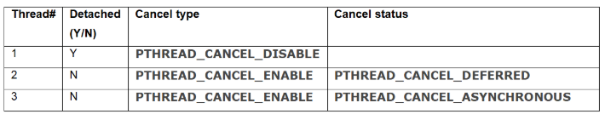

a. Let all the threads read and display their detach, cancel type and status and then display thread specific message as below.

T1: Display message in the format as below every 2 secs

<timestamp> Health OK

T2: Print numbers starting from 1000 in steps of 2 at an interval of 3 secs in format as below.

<timestamp> <threadid> <countvalue>

T3: Print numbers starting from 2000 in steps of 2 at an interval of 3 secs

<timestamp> <threadid> < countvalue >

b. After creating threads, and after 3 minutes from main(), cancel all 3 threads

c. From an other terminal, use command below to view the thread count of your program

§ ps -eLF

§ top [For top command usage to refer https://www.golinuxcloud.com/check-threads-per-process-count-processes/ ]

d. What difference did you observe between top and ps command?

e. Which column shows the number of threads in ps and in top commands?

f. Check the last message timestamp from the threads

g. Which thread was cancelled first and why?

h. Were all 3 threads cancelled? Justify the observation

